Turning Off Sales History on Picking Tickets

In Point of Sale (POS):
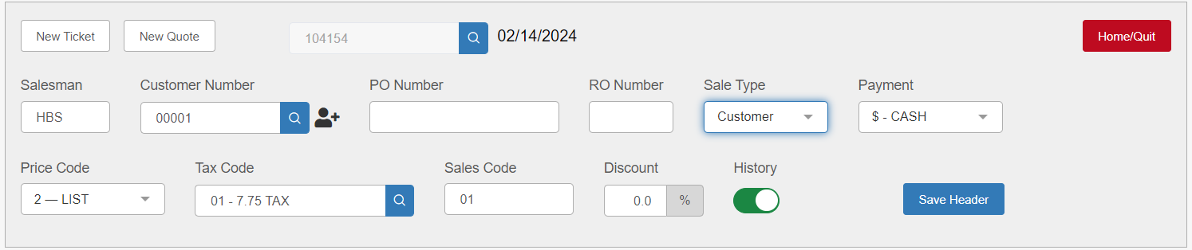
When creating a picking ticket in POS, you will see an option labeled “History” in the ticket header. If the switch is pushed to the right, causing the option to appear green, then sales history for the picking ticket is turned on.
To turn sales history off, click the switch to change its position to the left, causing it to turn grey:
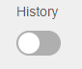
Click Save Header to save the setting.

In Repair Order Maintenance (ROM):
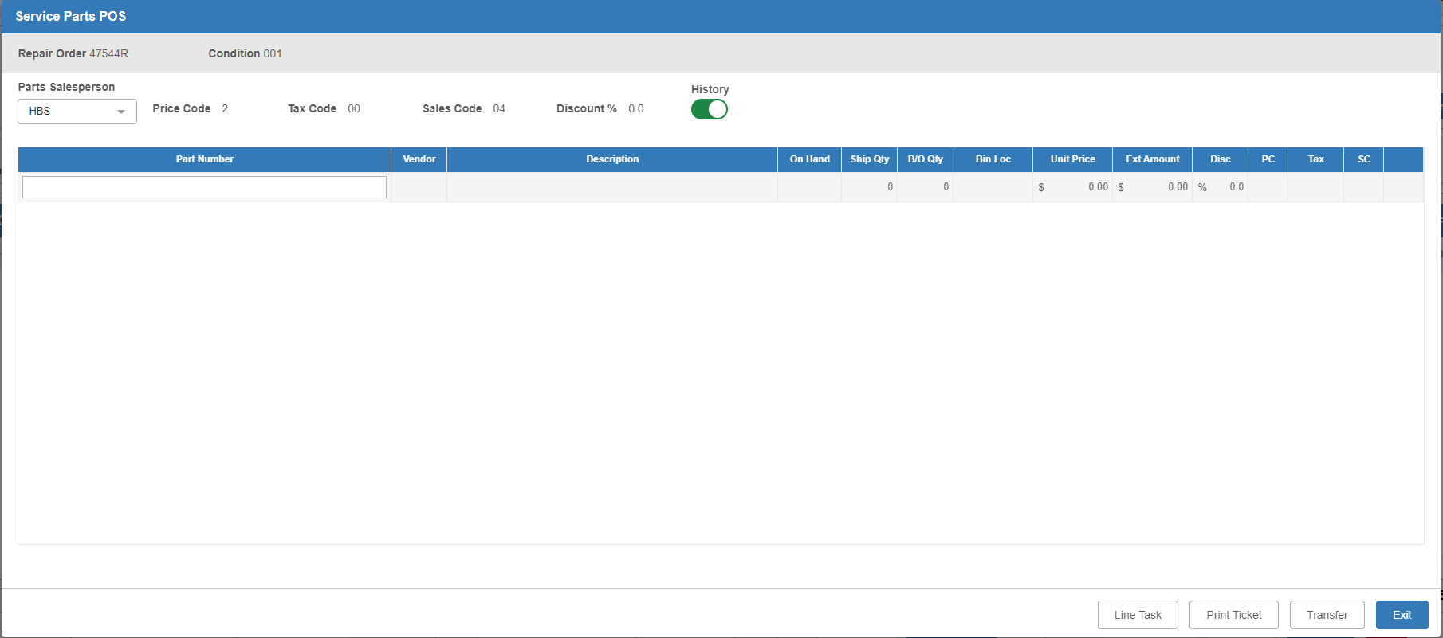
When creating a picking ticket in the Service Parts POS screen in ROM, you will see an option labeled “History” in the ticket header. If the switch is pushed to the right, causing the option to appear green, then sales history for the picking ticket is turned on.
To turn sales history off, click the switch to change its position to the left, causing it to turn grey:

The screen saves the option the moment you make the change, so if you click Exit and then reopen the modal, the sales history will still be turned off.

